27.10: a) The total flux must be zero, so the flux through the remaining surfaces must be 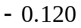Wb.
b) The shape of the surface is unimportant, just that it is closed.

c)
